**MyContact App**

**Requirement:**

Minimum SDK Version: 28

App Version:1.0

Contact room database version: 1

Front End: **Kotlin**

Project Architecture: **MVP (Model View Presenter**)

Contact Back End: **Room Database**

Login Sign Up Back End: **Firebase**

**Functionalities:**

1. **Login & Signup:**

* Login & Signup activity is done using basic **Firebase Authentication**.
* **LoginPresenter** will take care of all SignIn, and SignOut functionality.
* Used **Shared Preferences** to check User Login.

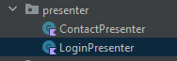

1. **Sign In: Firebase Basic mail/password Authentication**

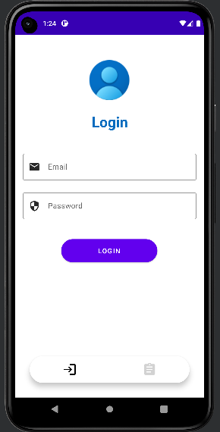

1. **Sign Up: Firebase Basic mail/password Sign up**

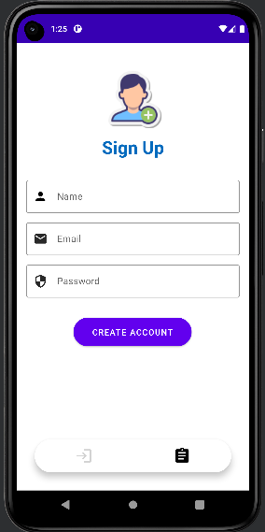

1. **Contact Dashboard & Edit Contact**:

List out all Local Contacts in Recycler View

**Runtime Cycler:**

**Fetch Contacts from Mobile -> Insert all contact to Room Database -> UI will fetch the contacts data from Room Database**

**Use case:**

* **User can track all mobile contacts easily**
* **User can modify the contact’s first name & last name.**
* **Sign Out: The user can sign out & login again with Login Activity.**

